Child Safe Standards
ORGANISATION REVIEW TEMPLATE

Why undertake a Child Safe Organisation Review?
It is vital that the leaders in your organisation have a clear understanding of how developed their child safety approaches are. Undertaking a Child Safety Review is a good place to start.

The Child Safe Standards Oganistaion Review Template has been developed to assist sporting organistaions identify what is currently in place and what needs to be developed in order to to meet the Standards.

How do I use the Organisation Review Template?
The Organisation Review Template addresses important areas of child safety and gives you the opportunity to assess whether your organisation is missing any of the essential ingredients.

To use the template:
- Identify to what degree your organisations meets each Child Safe Item
- List how your organistaion does this. Be specific and include key documents, links and events wherever possible
- Identify how your organisdtaion can better meet the Child Safe Items
- Nominate who shall undertake each item, by when and any review dates required

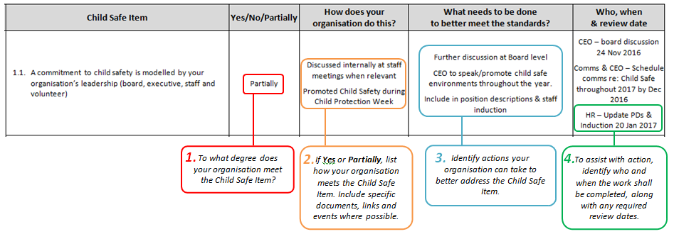

Once you have completed the checklist, prioritise each of the action items and use this information to form your Action Plan.

Child Safe Standards
ORGANISATION REVIEW TEMPLATE
 | Child Safe Item | Yes/No/Partially | How does your organisation do this? | What needs to be done  to better meet the standards? | Who, when  & review date
STANDARD 1  Culture of Child Safety | - A commitment to child safety is modelled by your organisation’s leadership (board, executive, staff and volunteer)
 | - Child safety is a core part of public and internal messages. i.e. part of your strategy and vision, included in your annual report and staff induction.
  - A culture exists within your organisation that supports the:
- Cultural safety Aboriginal children
- Cultural safety of children from culturally & linguistically diverse backgrounds
- Safety of children with a disability
 | - A culture exists in which staff, volunteers, children and families feel comfortable and supported when talking about child safety concerns
 | - Policies and practices exist that prioritise child safety and promote a shared responsibility to creating a child safe environment
 | - Your organisation raises awareness about child abuse
 | - Your organisation recognises, respects and promotes the belief that cultural identify is fundamental to a child’s safety and wellbeing
 | - Your organisation provides training about Child Safety to staff and volunteers
 | - Your organisation is aligned with your National Sporting Organisation and its approach to child safety
STANDARD 2  Child Safe Policy | - Your organisation has a child safe policy and/or statement of commitment, which is accessible to the public
 | - The Child Safe Policy specifically addresses the risks that have been identified in your risk assessment
 | - You undertake regular Child Safety Reviews (such as this) to inform your policy
 | - Your Child Safe Policy promotes the cultural safety of Aboriginal children and children from culturally and/or linguistically diverse backgrounds and the safety of children with a disability?
 | - Your Child Safe Policy includes requirements relating to Failure to Disclose and Failure to Protect legislative requirements?
 | - Your Child Safe Policy is in alignment with the approach of your National Sporting Organisation
STANDARD 3  Code of Conduct | - There is a Code of Conduct that explains acceptable and unacceptable behaviour of staff, volunteers and children
 | - The Code of Conduct is well known by your organisation's staff, volunteers, children and families and they are required to comply with it
 | - Your policies clearly explain how concerns regarding the Code of Conduct can be raised and how breaches of the Code of Conduct will be responded to
 | - You have considered if additional Codes of Conduct are required (such as applying to parents or children)
 | - Your Code of Conduct is in alignment with your National Sporting Organisations Child Safe Framework
STANDARD 4  Human Resource Practices | - You have clear position descriptions for staff and volunteers that includes the organisations commitment to child safety
 | - You have documented recruitment procedures including interview processes, referee checks, Working with Children Checks and other screening requirements
 | - Staff and volunteers are trained in child safety, understand and practice appropriate behaviour, including with Aboriginal children, culturally and/or linguistically diverse children and children with a disability respectively
 | - You have robust staff and volunteer performance management strategies in place
STANDARD 5  Responding and Reporting | - You have a process for reporting and acting on disclosures or concerns about child safety
 | - Your staff and volunteers are aware of their responsibility to report concerns of harm
 | - You have policies and procedures concerning record keeping requirements, confidentiality and privacy
 | - You have a complaints process that is accessible for children and families
 | - You have child friendly processes in place to ensure children know who to talk to if they feel unsafe or have a concern
 | - The organisation understands that if an allegation of abuse concerns an Aboriginal child, culturally and/or linguistically diverse child or child with a disability, particular measures should be taken to support the child
STANDARD 6  Identify & Remove Risks | - Your organisation undertakes risk assessments and has an organisational Risk Management Plan
 | - Undertaking, monitoring and reviewing the risk management plan the designated responsibility of a specific staff member
 | - In undertaking your risk assessment, you specifically consider the cultural safety of Aboriginal children and children from culturally and/or linguistically diverse backgrounds and the safety of children with a disability
STANDARD 7  Participation of Children | - Reporting procedures are accessible for all children
 | - Children have been given information to understand their rights and how to raise any concerns
 | - Children can expect to feel safe, empowered and taken seriously if they raise concerns
 | - Measures are taken to promote the cultural safety of Aboriginal children, the cultural safety of culturally and/or linguistically diverse children and the safety of children with a disability

Further Information:

Vicsport
03 9698 8100
admin@vicsport.com.au
www.vicsport.com.au/child-safe-standards

This resource is supported by the Victorian Government.

This document was developed utilising and adapting content from:
State Government of Victoria, Department of Health & Human Services (2015) An overview of the Victorian child safe standards
Commission for Children and Young People (2015), A guide for creating a child safe organisation 2.0

