Child Safe Standards
CLUB REVIEW TEMPLATE

Why undertake a Child Safe Sport Review?
It is vital that the leaders in your club have a clear understanding of your approach to providing a child safe environment. Undertaking a Child Safe Sport Review is a good place to start. This Child Safe Standards Club Review Template has been developed to assist sporting clubs identify what is currently in place and what needs to be developed in order to to meet the Standards.

Where do we start?

- Develop a Sub-Committee or Working Group
It is recommended that the process of implementing the Standards could be overseen by a sub-committee or working group in order to share the workload and provide an opportunity for individuals beyond the committee to get involved. For example, you may have a club member who is a teacher or police officer and they may be willing to provide their experience and insight into the process to strengthen your clubs action.

- Undertake a Club Review
The Club Review Template addresses important areas of child safety and gives you the opportunity to assess whether your club is missing any of the essential ingredients. It is recommended that multiple people complete the review, either as a collective or individually. This provides a more rounded assessment of the current position your club may be in. You may consider individuals representing the following areas of your club to complete the review:
- Committee member
- Coach
- Official/Umpire
- Volunteer
- Participant
- Parent
- Child/Youth (with the approval and assitance of their guardian).

DISCLAIMER:
While all care has been taken in the preparation of this document, none of the author(s) or Vicsport including its officers, employees and agents, make any representation or warranty as to, or take any responsibility for, the accuracy, reliability, completeness or currency of any information or recommendations contained in this document, nor its usefulness in achieving any purpose. Vicsport is not liable to users of this document for any loss or damage however caused resulting from the use of this document, and accepts no responsibility for the accuracy of the information or your reliance upon it. Vicsport recommends users seek independent legal advice to ensure compliance with the Child Wellbeing and Safety Act and the Child Safe Standards. Vicsport reserves all of its rights.
- To use the template:
- Identify to what degree your club meets each child safe item.
- List how your club does this. Be specific and include key documents, links and events wherever possible.
- Identify how your club can better meet the child safe items.
- Nominate who shall undertake each item, by when and any review dates required.
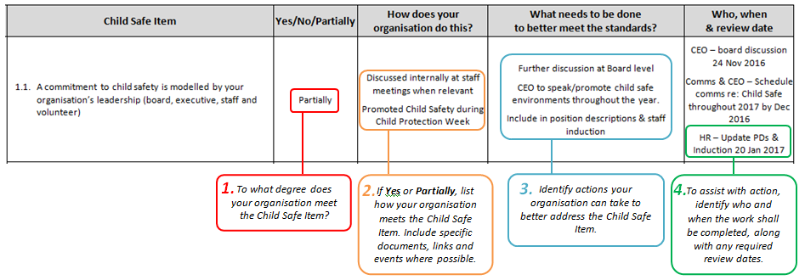

- Where to from here?
Once you have completed the checklist:
- Prioritise each of the action items and use this information to develop your Action Plan.
- Make child safe sport a standing agenda item at committee meetings.
- Report on your club’s progress to members on a regular basis to keep everyone informed. This could be in the from a face to face update at meetings, a short post on social media, a longer article in your newsletter or a post on your website.

Remember:
Developing a child safe culture within your club is not a one-off exercise. This is the beginning of long term cultural change that will require ongoing effort and commitment from everyone in your club. It is also a legal requirement within Victoria as of 1 January 2017.

Further Information:
Your club is not alone in taking steps to foster a child safe culture and meet the Standards. There are lots of organisations who can assist you with your journey. For information or assistance, contact your State Sport Association, Regional Sport Assembly or Local Government Agency. Other sporting clubs may also be a good source of practical ideas and strategies.

Vicsport also has resources and information available. Contact us via:
03 9698 8100
admin@vicsport.com.au
www.vicsport.com.au/child-safe-standards

Child Safe Standards
CLUB REVIEW TEMPLATE
 | Child Safe Item | Yes/No/Partially | How does your club do this? | What needs to be done  to better meet the standards? | Who, when  & review date
STANDARD 1  Culture of Child Safety | - A commitment to child safety is modelled by your club’s leadership (committee, staff (if any), volunteers and key personnel).
 | - Child safety is a core part of public and internal messages. i.e. part of your strategy and vision.
  - A culture exists within your club that supports the:
- Cultural safety Aboriginal children
- Cultural safety of children from culturally & linguistically diverse backgrounds
- Safety of children with a disability

 | - A culture exists in which everyone including children and families feel comfortable and supported when talking about child safety concerns.
 | - Policies and practices exist that prioritise child safety and promote a shared responsibility to creating a child safe environment.
 | - Your club raises awareness about child abuse.
 | - Paid staff and volunteers are trained in child safety, understand and practice appropriate behaviour, including with Aboriginal children, culturally and/or linguistically diverse children and children with a disability respectively.
STANDARD 2  Child Safe Policy | - Your club has a Child Safe Policy or Statement of Commitment that specifically addresses the risks that have been identified in your club risk assessment.
 | - Your Child Safe Policy or Statement of Commitment is widely communicated throughout your club and freely accessible.
 | - You undertake regular Child Safety Reviews (such as this) to inform your policy or statement of commitment.
 | - Your Child Safe Policy promotes the cultural safety of Aboriginal children and children from culturally and/or linguistically diverse backgrounds and the safety of children with a disability?
 | - Your Child Safe Policy includes requirements relating to Failure to Disclose and Failure to Protect legislative requirements?
 | - Your Child Safe Policy is in alignment with the approach of your State & National Sporting Organisations
STANDARD 3  Code of Conduct | - Your club adopts a Code of Conduct (or embeds child safety into current codes) that explains acceptable and unacceptable behaviour for everyone involved in your club.
 | - The Code of Conduct is well known by your club's staff, volunteers, children and families and they are required to comply with it.
 | - Your policies clearly explain how concerns regarding the Code of Conduct can be raised and how breaches of the Code of Conduct will be responded to.
 | - Your Code of Conduct is in alignment with your State & National Sporting Organisations Child Safe Framework.
STANDARD 4  Human Resource Practices | - You have clear position descriptions for staff and volunteers that include the club’s commitment to child safety.
 | - You have documented recruitment procedures including (where appropriate) interview processes, referee checks, Working with Children Checks and other screening requirements.
 | - Training opportunities are provided to throughout your club to inform individuals of the Standards and what constitutes appropriate behaviour (i.e. Play By The Rules online training, discussion at start of year meeting, included in coach/official education).
STANDARD 5  Responding and Reporting | - You have a process for reporting and acting on disclosures or concerns about child safety.
 | - Individuals involved in your club are aware of their responsibility to report concerns of harm.
 | - You have policies and procedures concerning record keeping requirements, confidentiality and privacy.
 | - You have a complaints process that is accessible to children and families.
 | - You have child friendly processes in place to ensure children know who to talk to if they feel unsafe or have a concern. This is widely communicated amongst your club.
 | - The organisation understands that if an allegation of abuse concerns an Aboriginal child, culturally and/or linguistically diverse child or child with a disability, particular measures should be taken to support the child.
STANDARD 6  Identify & Remove Risks | - Your club undertakes risk assessments and has a Risk Management Plan in place.
 | - Responsibility for undertaking, monitoring and reviewing the risk management plan is designated to key club personnel.
 | - In undertaking your risk assessment, you specifically consider the cultural safety of Aboriginal children and children from culturally and/or linguistically diverse backgrounds and the safety of children with a disability.
STANDARD 7  Participation of Children | - Reporting procedures are accessible for all children.
 | - Children are given age appropriate information to help them understand their rights and how to raise any concerns.
 | - Children can expect to feel safe, empowered and taken seriously if they raise concerns.
 | - Measures are taken to promote the cultural safety of Aboriginal children, the cultural safety of culturally and/or linguistically diverse children and the safety of children with a disability.

DISCLAIMER:
While all care has been taken in the preparation of this document, none of the author(s) or Vicsport including its officers, employees and agents, make any representation or warranty as to, or take any responsibility for, the accuracy, reliability, completeness or currency of any information or recommendations contained in this document, nor its usefulness in achieving any purpose. Vicsport is not liable to users of this document for any loss or damage however caused resulting from the use of this document, and accepts no responsibility for the accuracy of the information or your reliance upon it. Vicsport recommends users seek independent legal advice to ensure compliance with the Child Wellbeing and Safety Act and the Child Safe Standards. Vicsport reserves all of its rights.

This resource is supported by the Victorian Government.

This document was developed utilising and adapting content from:
State Government of Victoria, Department of Health & Human Services (2015) An overview of the Victorian child safe standards
Commission for Children and Young People (2015), A guide for creating a child safe organisation 2.0

